- Using fertilizers in farming is an example of
- No cost production
- Low cost production
- High cost production
- None of these
- What is the process of growing two or more crops in a definite pattern?
- Crop rotation b) Inter-cropping c) Mixed cropping d) Organic cropping
- Which of the following is an energy yielding crop?
- Wheat b) Mustard c) Gram d) Groundnut
- Arrange these statements in correct sequence of preparation of green manure.
- Green plants are decomposed in soil
- Green plants are cultivated
- Plants are ploughed
- Decomposition
- i---ii---iv—iii b) ii—iii---i—iv c) ii---iii—iv—I d) iii—ii—iv—i
- The leguminous crop whose seeds are rich source of edible oil is
    - Groundnut. B) Sunflower C) Linseed. D) Lentil
- Crop variety improvement is done for the following reasons, except
    - Increased productivity of crop per unit area
    - Tallness and profused branching of cereal crops
    - Baking quality of wheat
    - Resistance to pests
- Bio fertilizers used in organic farming include
    - Symbiotic and free living nitrogen fixing bacteria
    - Nitrogen fixing cyanobacteria
    - Phosphate soluble microorganisms
    - All of these
- Which of the following is true for crop rotation?
    - Growing two or more crops simultaneously in same piece of land
    - Growing different crops in pre planned succession
    - Definite pattern is maintained
    - Seeds are mixed before sowing
- Which of the following is not an advantage of using fertilizers?
    - It causes water pollution due to surface run off
    - They are compact and nutrient specific
    - They can change pH
    - Both a and c
- Which of the following is not true about essential nutrients for plants?
    - Total 16 nutrients are required for plants
    - 13 nutrients of 16 are supplied from soil
    - Non-mineral nutrients like Carbon, Hydrogen and Chlorine are supplied through air and water
    - Nitrogen, Phosphorus and Potassium are considered as primary nutrients

- The figure shows two crop fields (plots A and B) have been treated by manures and chemical fertilizers respectively, keeping other environmental factors the same. Observe the graph and answer the following question.
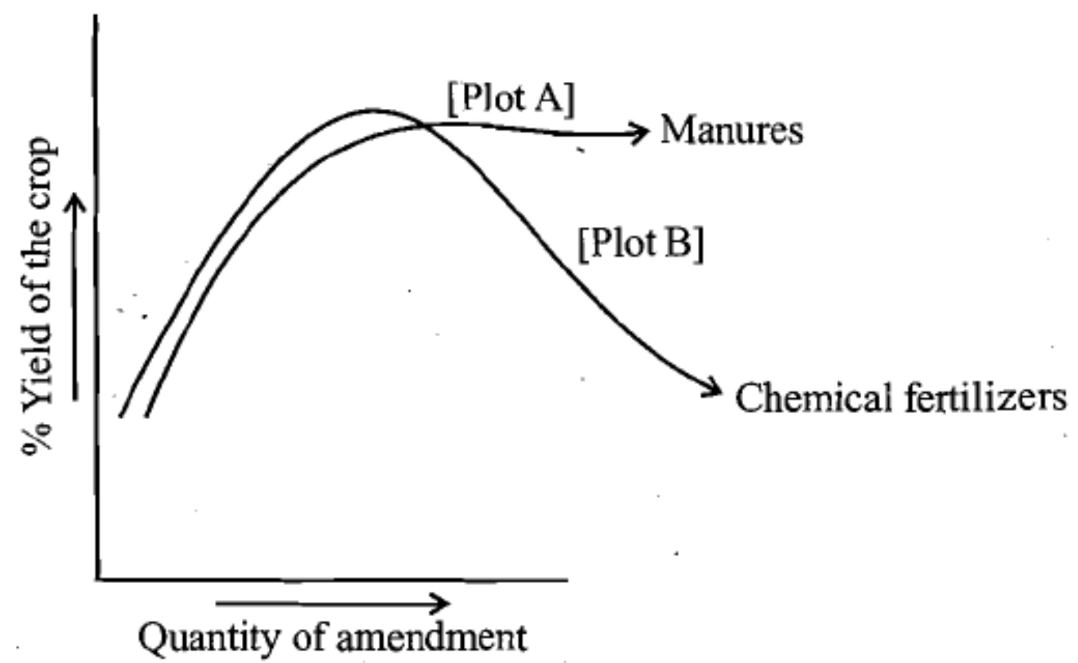

  - Why does plot B show a sudden increase and then a gradual decrease in yield?
  - Why the highest peak of the graph in plot A is slightly delayed?
  - What is the reason of different patterns of two graphs?
- Which of the following conditions will give the most benefits? Why?
    - Farmers use high-quality seeds do not adopt irrigation or use fertilizers.
    - Farmers use ordinary seeds adopt irrigation and use fertilizer.
    - Farmers use quality seeds adopt irrigation use fertilizer and use crop protection measures.
- Why legume crops do not require nitrogenous fertilizers?
14. Define GM crop. Name one such which is found in India.
15. Mention two biological control methods used for crop protection.
16. Name the factors that are responsible for losses of grains during storage.
17. How plants gain nutrients?
18. State two biotic and abiotic factors that can affect crop production. Mention how to get rid of it.

